**Please ensure all PE kit is clearly labelled with your child’s name**

PE Kits can also be purchased from Tesco, Asda, Matalan, Primark etc

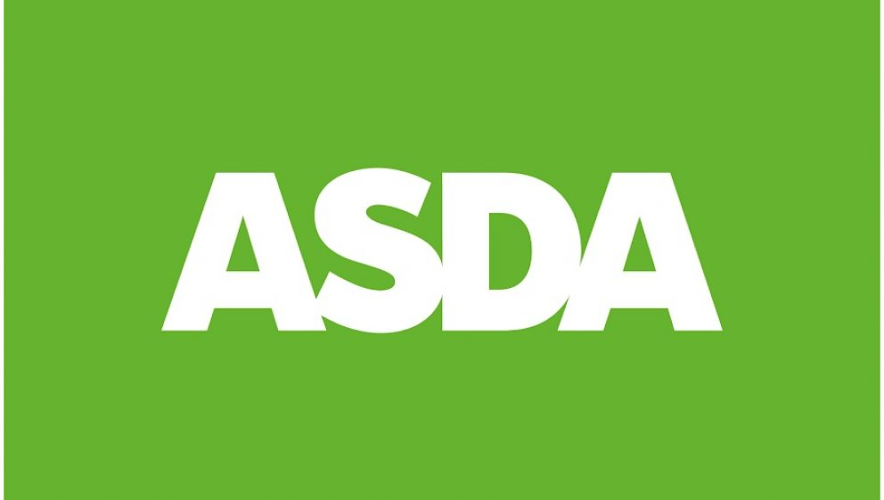 

 

**PE kits to be in school by:**



Due to health and safety draw string bags can no longer be used.

PE bags can be purchased from the National School wear Centre in Hanley.

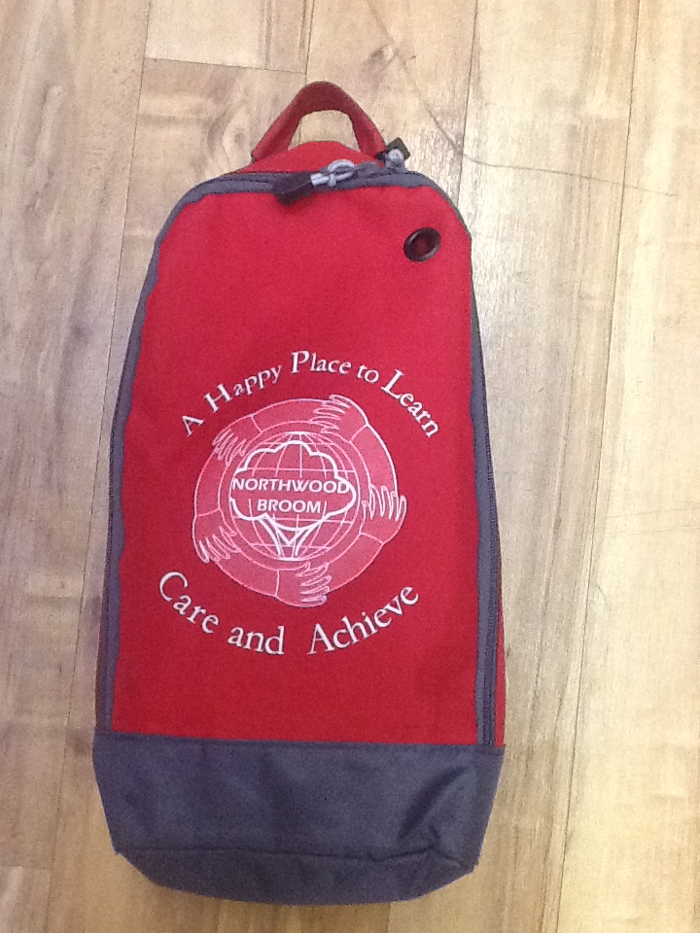 

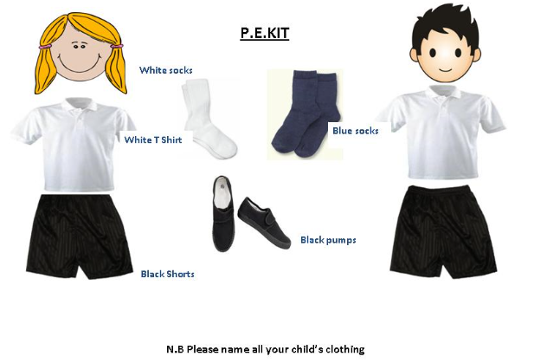

**Nursery PE Kit**

+